AWS TASK

Create a windows Vm machine in AWS and connect with RDP open CMD in windows share the about system info.

A virtual machine is a software based emulation of a physical computer, running its own os and applications on virtualized hardware like cpu , memory and storage all managed by a hypervisor on a single physical “host” machine

VMs Work:
A physical computer or host runs virtualization software a hypervisor this software physical hardware resources to one or more guest vms

HOST & GUEST

Each VM operates with its own set of virtual hardware, including a CPU, RAM, and storage all simulated by a hypervisor
VMs are isolated from each other and the host, meaning a problem in one VM Typically wont affect others
ISOLATION
A vm has its own operating system, which functions independently of the host os and other vms
GUEST OPERATING SYSTEM
VIRTUAL HARDWARE
RDP CONNECTION IN VM :

VM is a virtual machine which is computer emulated in software that you connect to remotely using the remote destop protocol instead of physical computer, your are connecting a simulated environement that runs into own operating system and applications all within a window of your local machine.

ITS WORKS WITH RDP:

- The rdp client on your computer connects to the rdp server running on the virtual machine

- This connection is established using the virtual machine ip address , which can be either a direct ip on a network or a forward port if the vm is behind a network address translator on the host machine.

- The connections sends the virtual machine display to your computer and sends your keystrokes and mouse movement back to the virtual machine making it feel as if your are using the machine directly

- This setup is commonly used in cloud service to provide access to virtual servers or desktop and it is also used on premises for tasks like running multiple server role on a single physical server or testing application in a sandbox environment

COMMAND PROMPT USING VIRTUAL MACHINE:

Command prompt in windows, you cannot directly “define” or create a virtual machine using built in cmd commands alone as cmd line interface for the windows os you can interact with manage vm using cmd or powershell in conjuction with virtualization software or cloud platforms.

- If you have hyper v enabled on windows you can use powershell command which can be executed from cmd by typing poweshell file to create configure start, and stop vms

- For other virtualization software like virtual box,you would use their specific command line tools egf. Vboxmanage for virtualbox within the command prompt to manage vm

TO CREATE A WINDOWS VM IN AWS CONNECT VIA RDP, OPEN COMMAND PROMPT AND RETRIEVE SYSTEM INFORMATION :

- LAUNCH A EC2 INSTANCES:

- Sign in to the aws management console and navigate to the ec2 dashboard

- Choose launch instances

- Select a windows server and amazon machine image such as microsoft windows server 2022 base

- Choose an instances type and configure network setting ensuring that a security group allowing rdp traffic (port 3389) from our ip address or a specfic range is associated.

- Create a new pair key or select an existing one. This key pair is used to descrypt the administrator password for the instance

- Review your setting and launch the instances.

- CONNECT THE INSTANCE VIA RDP:

- Once the instance status shows running select in the ec2 instances list

- Choose the connect and select the rdp client tab

- Choose get password upload your key pair file and descrypt the password make a note of this password

- Download the remote desktop file

- Open the download rdp file whem prompted enter the descrypt administrator password and connect

- OPEN COMMAND PROMPT AND RETRIEVE SYSTEM INFORMATIONS :

- After sucessfully connecting you will see the windows desktop of your ec2 instances

- Press windows key + R to open the run dialog

- Type cmd and press enter to open command prompt

- In the command prompt window, type systeminfo and press enter.

- SHARE SYSTEM INFORMATION:

- The system info command will display detailed system information about the window ec2 instances. We can copy this output from the command prompt windows to share it.

When connecting to a Remote Desktop Protocol (RDP) Session, you can share local system information from your client device with the remote server. This process is known as device or resource redirection. The most common resources are local drives, printers.

Windows 10
Macbook 1 connected isp 1
Vm win 10
RDP PUBLIC IP HOST PUBLICIP

ISP 2
ISP

- Open the remote desktop connection app by searching for “mstsc” or “Remote Desktop Connection ” in the start menu.

- Click Show Options in the bottom-left corner to expand the full configuration menu.

- Navigate to the Local Resources tap.

- In the “local device” and resources selection.

DRIVERS: Allows access to your local hard drives, USP drives. And other storage media from within the remote session.

PRINTERS: Redirects your local printer so you can print documents from the remote computers.

CLIPBOARD: Enables the seamless copying and pasting of text files between your local computers and the remote session.

System locate : en-gb; english (india)
Input locate : 000409
Time zone : (utc+5 :30) chennai
Total physical memory : 65, 293 mb
Available physical memory : 42,473 mb
Virtual memory : max size: 75,021 mb
Virtual memory : Available : 49,229 mb
Page file location : c:\pagefile.sys
Domain : workgroup
Logon server: \\h2smedia
Hotfix(s): 3 hotfix installed
[01] : kb5033921
[02] : kb5035384
[03]: kb5035428

Network card : 5 nics installed
[01] : display link network adapter ncm connection name : ethernet -3
Status : media disconnected

[02] : realtek gaming : 5gbe family controller
Connection name : ethernet
Status : media disconnected

[03]: virtual box host only ethernet adapter
Connection name: ethernet 2
DHCP Enabled : no
Ip address(s)
[01]: 192.168.56.1
[02]: fe80::7624 :d729:7327: 294f
[04]: intel®wifi 6e ax211 160mhz
Connection name : wifi
DHCP Enabled : yes
DHCP Server : 192.168.1.1

Ip addresses
[01]: 192.168.1.9
[02]: fe80::f83b:1163: 100d:cdc4
[05]: bluetooth device (personal area network)
Connection name : bluetooth network connection 2
Status : media disconnected

Virtualization - based security : status : not enabled
App control for business policy : enforced
App control for business user mode policy : off
Security features enabled.

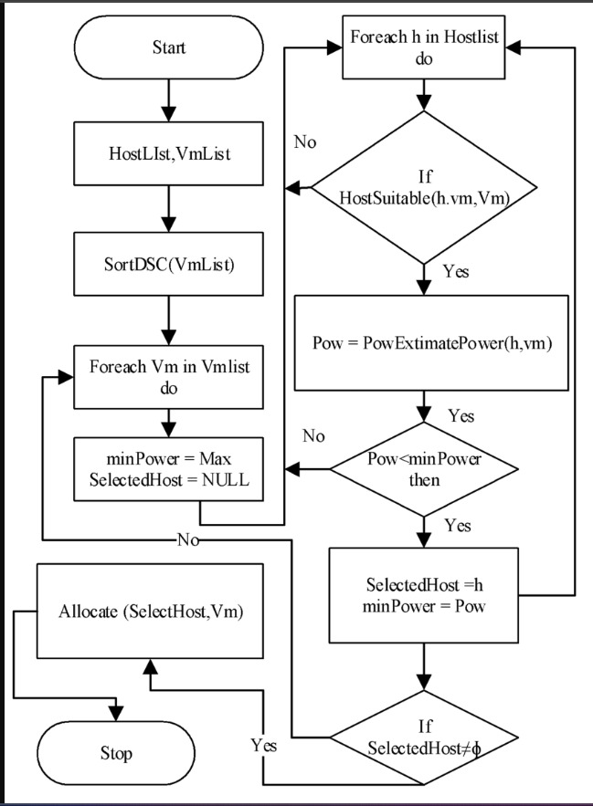

OPEN CMD AND VIEW SYSTEM INFORMATION :

- Press win +R, type cmd, and press enter

- In command prompt type :

System info

- This command will display details :

- Os name and version

- System manufacturer

- Processor

- Total physical memory

- Network cards

- Host name & domain

